# Summary of Current Literature

(Most Relevant Stuff - additional documents in this folder)

## (Fujii paper) A microfluidic device for on-chip agarose microbead generation with ultralow reagent consumption

Link: <http://www.ncbi.nlm.nih.gov/pmc/articles/PMC3482248/>

Bead size: 20 µm - 55 µm

Device: PDMS

Novelty: “Push-Pull” method on a single chip

Notes:

* ***This is LMP agarose.*** I tried replicating it, but could never get it to work

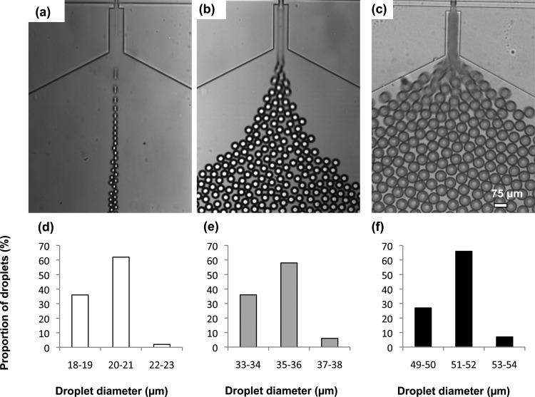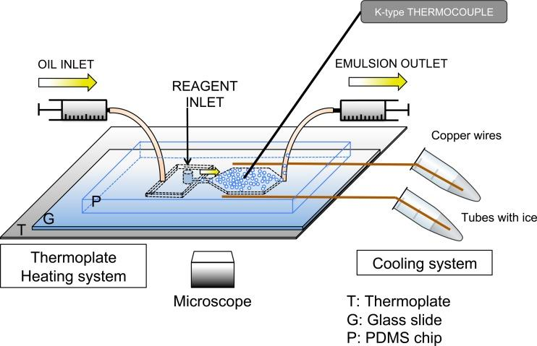

## High-throughput generation of hydrogel microbeads with varying elasticity for cell encapsulation

Link: <http://www.sciencedirect.com/science/article/pii/S0142961210013402>

Bead size: 100 µm

Device: PDMS

Novelty: Control elasticity of agarose beads for proper cell expression when encapsulated

Notes:

* ***Not low melting point agarose***
* The dead volume was heated in an oven and the surface of the chip was cooled
* Exit channel was cooled by a water circulator filled with water + glucose at 2°C then were placed in an ice bath for 45 minutes

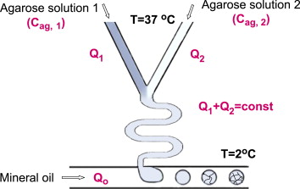

## Encapsulating bacteria in agarose microparticles using microfluidics for high-throughput cell analysis and isolation

Link: <http://www.ncbi.nlm.nih.gov/pmc/articles/PMC3060957/>

Bead size: 22 µm - 45 µm

Device: PDMS

Novelty: PDMS for monodisperse microparticles

Notes:

* ***Not low melting point agarose***
* Heated syringe and device to 40°C
* FACS - high throughput fluorescent bacteria detection system

## Highly Parallel Single-Molecule Amplification Approach Based on Agarose Droplet Polymerase Chain Reaction for Efficient and Cost-Effective Aptamer Selection

Link: <http://pubs.acs.org/doi/abs/10.1021/ac2026942>

See also:

<http://pubs.rsc.org/en/content/articlelanding/2010/lc/c0lc00145g#!divAbstract>

And:

<http://pubs.acs.org/doi/full/10.1021/ac2033084>

Bead size: 40 µm - 120 µm

Device: Glass

Novelty: screening aptamers from ssDNA library by single-molecule emulsion PCR inside of agarose droplets

Notes:

* ***This is low melting point agarose***

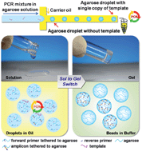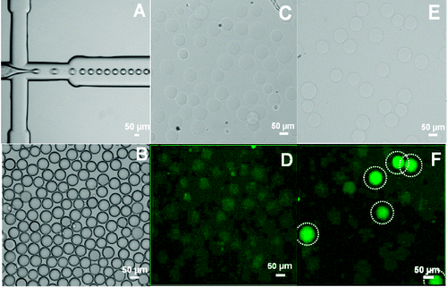

# Related Literature

**Simple method for the production of agarose bioparticles**

Link: <http://link.springer.com/article/10.1023/A:1008821407995>

Novelty: Simple extrusion of agarose + yeast into a cold beaker

**Application of gel microdroplet and flow cytometry techniques to selective enrichment of non-growing bacterial cells**

Link: <https://femsle.oxfordjournals.org/content/197/1/29>

Novelty: Flow Cytometry method - (50 µm beads created by membrane emulsion)

**Preparation of uniform-sized agarose beads by microporous membrane emulsification technique**

Link: <http://www.sciencedirect.com/science/article/pii/S0021979707002330>

Novelty: membrane emulsification by nitrogen gas (60 µm) - not LMP

**Uniform and high throughput agarose gel micro droplet generation device for single cell analysis**

Link: <https://waseda.pure.elsevier.com/en/publications/uniform-and-high-throughput-agarose-gel-micro-droplet-generation->

Novelty: Very low variation in droplet size (50 µm) for bacteria encapsulation

**Fabrication of superporous agarose beads for protein adsorption: effect of CaCO3 granules content.**

Link: <http://linkinghub.elsevier.com/retrieve/pii/S0021-9673(10)00966-0>

Novelty: 50 µm diameter beads produced for chromatography

**Drying of Agarose Gel Beads**

Link: [Springer](http://download.springer.com/static/pdf/388/art%253A10.1007%252FBF02154242.pdf?originUrl=http%3A%2F%2Flink.springer.com%2Farticle%2F10.1007%2FBF02154242&token2=exp=1465472742~acl=%2Fstatic%2Fpdf%2F388%2Fart%25253A10.1007%25252FBF02154242.pdf%3ForiginUrl%3Dhttp%253A%252F%252Flink.springer.com%252Farticle%252F10.1007%252FBF02154242*~hmac=f37254ce518fdf17633d7d64734c50108e9180d6d287e549438b4b86c67f14ac)

Novelty: Slow-drying process with acetone and later crosslinking creates non-porous beads, but increases the melting temperature

**Manufacture by water/oil emulsification of porous agarose beads: Effect of processing conditions on mean particle size, size distribution and mechanical properties**

Link: <http://www.sciencedirect.com/science/article/pii/S0255270105000668>

Novelty: Study on the single stirred vessel for agarose bead production ( ≥ 200 µm)

**General methods to render macroporous stationary phases nonporous and deformable, exemplified with agarose and silica beads and their use in high-performance ion-exchange and hydrophobic-interaction chromatography of proteins**

Link: <http://link.springer.com/article/10.1007/BF02290503>

Novelty: Drying then crosslinking to remove porous features, but increases melting temperature

**Encapsulating Bacteria in Agarose Microparticles Using Microfluidics for High-Throughput Cell Analysis and Isolation**

Link: <http://pubs.acs.org/doi/full/10.1021/cb100336p>

Novelty:

**PLGA**: <http://onlinelibrary.wiley.com/doi/10.1002/app.41566/full> (Tm>120°C)